SIMATS ENGINEERING (SAVEETHA SCHOOL OF ENGINEERING)
Department of Computer Science and Engineering
CO5 ASSESSMENT TOOL 2
SEMINAR ON EMERGING TECHNOLOGIES
CO5: Evaluate emerging technologies and societal impacts, maintaining and evolving software systems responsibly.
Student Details | Information
Student Name | Rishitha. Y
Register Number | 192424233

Assessment Details
Item | Details
Assessment | Assessment Tool 2 – Seminar on Emerging Technologies
Weightage | 20%
Total Marks | 25
Duration | 60 minutes

Declaration
I certify that this submission is my original academic work and that I have followed the guidelines specified for the assessment. The seminar is organized around the required introduction, motivation, architecture, technologies, applications, advantages, limitations, recent developments, challenges, case study, conclusion, and references.

Purpose of the Seminar
This document provides a structured seminar format for presenting an assigned emerging technology in Software Engineering. It is designed to support clear technical explanation, practical examples, critical evaluation, and responsible consideration of the technology's societal impact.

.CONTENT – SEMINAR ON EMERGING TECHNOLOGIES
The following additional material expands the supplied seminar framework while retaining its original organization. It provides fuller explanations, practical evaluation points, and visual diagrams that can be used during seminar presentation.
Emerging technologies are important in Software Engineering because modern software systems must respond to changing requirements, larger workloads, connected devices, security threats, and increasing expectations for speed and reliability. A technology should therefore be evaluated not only for novelty, but also for its ability to solve a clearly identified problem and to be maintained responsibly over time.
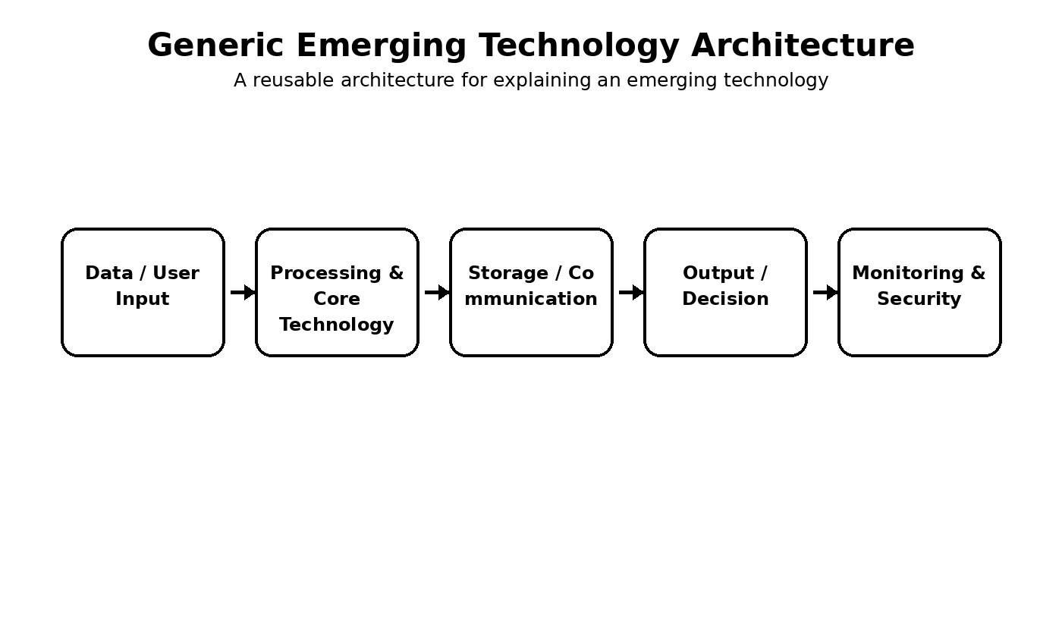
Figure 1. Generic architecture for presenting an emerging technology.

1. Introduction and Background
An emerging technology generally represents a new or rapidly developing technical capability whose adoption can influence the way software is designed, developed, tested, deployed, operated, or maintained. Examples may include artificial intelligence, edge computing, Internet of Things, blockchain, extended reality, quantum computing, digital twins, and advanced cloud-native platforms. The selected technology should be introduced through its meaning, background, evolution, purpose, and relevance to software engineering.
The evolution of a technology is usually driven by a combination of increasing computational capability, better connectivity, availability of data, advances in algorithms, changing business requirements, and demand for automation. During a seminar, explaining this evolution helps the audience understand why the technology is receiving attention and what limitations of earlier approaches it attempts to address.
- Problem orientation: begin with the practical or technical problem before describing the technology.
- System orientation: explain where the technology fits within the complete software system.
- Evidence orientation: distinguish established capabilities from proposed or experimental ideas.
- Responsible orientation: discuss security, privacy, accessibility, maintainability, and societal effects.

2. Need and Motivation
The motivation for adopting an emerging technology should be linked to a specific limitation in an existing solution. These limitations may involve slow processing, inability to scale, manual effort, high operational cost, poor user experience, security weaknesses, or difficulty handling continuously growing data. A strong seminar explains the relationship between the existing problem, the proposed technology, and the expected improvement.
Existing challenge | Possible technology contribution | Expected impact
Increasing workload | Scalable processing or distributed architecture | Improved scalability
Manual repetitive tasks | Automation or intelligent decision support | Reduced effort and faster operation
Real-time requirements | Edge or event-driven processing | Lower response delay
Complex data processing | Advanced analytics or AI techniques | Improved insight and decision support
Security and trust requirements | Stronger security and privacy mechanisms | Safer system operation

Motivating Factors
- Improved performance and efficiency
- Scalability for growing users, data, or workloads
- Automation and intelligent decision-making
- Better user experience and accessibility
- Security, privacy, reliability, or sustainability requirements
- Reduction of operational cost or development effort

Expected Impact
The seminar should explain the expected technical, operational, economic, and societal impact of the technology. Benefits should be balanced with possible risks and responsible-use considerations.

3. Working Principle / Architecture
A clear working principle should trace information from input to processing and finally to output. The architecture can also show storage, communication, security, monitoring, and feedback. This makes the seminar easier to understand because the audience can see how individual components interact rather than viewing the technology as an isolated concept.
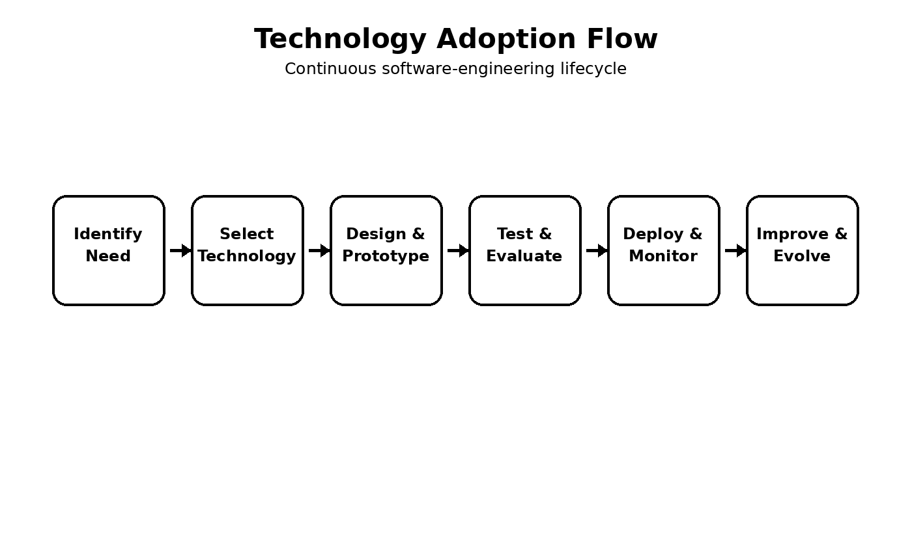

Figure 2. Technology adoption and continuous improvement flow. Architecture Components
- Input or data sources
- Processing or computation layer
- Core algorithm, model, platform, or service
- Storage, communication, or integration layer
- Output, user interface, or decision layer
- Monitoring, security, and maintenance mechanisms

Suggested Diagram
Draw a labelled architecture showing: Input → Processing/Core Technology → Output, with security, storage, communication, and monitoring components where applicable.
A useful explanation is to describe each stage in sequence: data or user input is collected; the processing layer prepares or transforms the information; the core technology performs its principal operation; the result is delivered to a user or another software component; and monitoring mechanisms observe performance, security, reliability, and maintenance needs. Feedback can then be used to improve the system.

4. Key Components and Technologies
The key components depend on the selected emerging technology, but a complete explanation normally covers data sources, computation, algorithms or models, communication, storage, interfaces, security, and deployment. It is also useful to explain how these components integrate with existing software engineering activities such as requirements analysis, architecture design, coding, testing, CI/CD, deployment, monitoring, and maintenance.
- Data layer – collects, cleans, stores, and manages information required by the system.
- Processing layer – performs computation, transformation, inference, or business logic.
- Core technology layer – contains the main algorithm, model, platform, or service.
- Integration layer – connects APIs, databases, devices, cloud services, and external systems.
- Security layer – supports authentication, authorization, privacy, integrity, and secure communication.
- Monitoring layer – measures reliability, performance, resource use, and operational behavior.

5. Applications and Real-World Use
Applications should demonstrate how the technology moves from a technical concept to a practical solution. Different domains can be compared because the same emerging technology may provide different benefits depending on the data, users, constraints, and risks of the environment.
Domain | Typical application area | Potential benefit
Healthcare | Decision support, monitoring, connected medical systems | Faster and more informed decisions
Education | Adaptive learning and intelligent learning platforms | Personalized learning support
Industry | Automation, predictive monitoring, smart manufacturing | Improved efficiency and reduced downtime
Smart systems | Connected sensing and real-time control | Faster response and resource optimization
Business / Services | Automation, analytics, recommendation and customer systems | Improved productivity and user experience

For the case study, the seminar should identify the problem, system context, technology used, implementation approach, outcomes, limitations, and lessons learned. The case study should be treated as evidence for evaluation rather than as a claim that the technology is suitable for every situation.

6. Advantages and Limitations
Advantages should be balanced with limitations. A technology may improve performance but require more resources; it may automate decisions but introduce new risks; or it may provide scalability but increase architecture complexity. Such trade-offs are important in responsible Software Engineering.
Evaluation area | Positive possibility | Important limitation to examine
Performance | Faster response or higher throughput | Hardware or computational requirements
Scalability | Supports larger workloads | Complexity can increase at scale
Automation | Reduces repetitive work | Incorrect automation may affect decisions
Cost | Can reduce long-term operational effort | Initial adoption and maintenance can be expensive
User experience | Can improve speed and personalization | Accessibility and usability must be validated
Security / privacy | Can enable stronger controls | New attack surfaces or data risks may appear

7. Recent Developments and Trends
Because emerging technologies change rapidly, recent developments should be discussed in terms of improved tools, better performance, new deployment models, standards, research directions, and industry adoption. The important point is to explain how the technology is evolving rather than simply listing new products or terms.
A useful technology-evolution structure is: earlier approaches established the basic concept; current approaches improve efficiency, integration, scalability, or usability; future approaches are expected to make systems more adaptive, interoperable, secure, sustainable, and easier to maintain. Responsible adoption requires testing, documentation, monitoring, privacy protection, and continuous evaluation.

8. Challenges, Future Scope and Societal Impact
Major challenges can arise from technical complexity, resource requirements, data quality, interoperability, security, privacy, cost, shortage of expertise, and uncertainty about long-term maintenance. Societal considerations may include accessibility, fairness, employment effects, safety, sustainability, and digital inclusion.
- Improve efficiency so that advanced capabilities can operate with practical resource requirements.
- Strengthen security and privacy throughout design, deployment, and maintenance.
- Improve interoperability so emerging technologies can work with existing systems.
- Evaluate solutions under broader and more realistic conditions before large-scale adoption.
- Design for maintainability so systems can evolve as the technology and requirements change.
- Monitor societal effects and introduce safeguards where technology may create unintended harm.

Architecture Components
- Input or data sources
- Processing or computation layer
- Core algorithm, model, platform, or service
- Storage, communication, or integration layer
- Output, user interface, or decision layer
- Monitoring, security, and maintenance mechanisms

Suggested Diagram
Draw a labelled architecture showing: Input → Processing/Core Technology → Output, with security, storage, communication, and monitoring components where applicable.

9. Expanded Case Study Guidance
A strong case study can be presented using a simple sequence: Problem → Existing limitation → Technology selected → Architecture/implementation → Evaluation → Outcomes → Limitations → Lessons learned. This sequence helps connect theory with practice and gives the audience a clear story to follow. Future Scope
Improve scalability and efficiency.
Develop stronger security and privacy mechanisms.
Reduce resource and operational requirements.
Improve interoperability and integration with existing systems.
Perform broader real-world evaluation.
Support responsible, sustainable, and maintainable software evolution.
Societal Impact
Explain possible effects on users, organizations, employment, privacy, accessibility, fairness, safety, sustainability, or digital inclusion. The discussion should consider both positive and negative impacts.
10. Expanded Conclusion
Emerging technologies can transform software systems when they are selected for a clearly identified need and integrated through sound engineering practices. The seminar should therefore combine technical explanation with critical evaluation. Understanding the working principle, components, applications, advantages, limitations, recent developments, challenges, and future scope gives a balanced view of the technology.
Responsible Software Engineering requires more than achieving short-term performance improvements. Security, privacy, maintainability, scalability, usability, sustainability, and societal impact should also be considered. Continuous monitoring and evolution are necessary because emerging technologies and their surrounding requirements change over time.

